GREENVALE PRIMARY SCHOOL
HEADLICE INFORMATION SHEET
Head Lice are tiny insects that live in human hair and are particularly common in children aged 4-11.

Research has shown that:
- Head Lice are spread by head-to-head contact, climbing (not jumping or flying) from the hair of an infected
person to the hair of someone else.
- A head Lice infestation is not the result of dirty hair or poor hygiene.
- All hair types can be affected, regardless of the length or condition.
- A Head Lice infestation may spread if individual Parents/Carers fail to treat their children.
- Infections may exist for up to 3 months before Head Lice become apparent.

Head Lice often cause a person’s scalp to itch. Itching isn’t caused by lice biting the scalp but by an allergy to the scalp. However, not everyone is allergic to head Lice so you or your child may not notice a Head Lice infestation. In some cases an allergy can take up to 3 months to develop so it is important to check your child’s hair regularly.
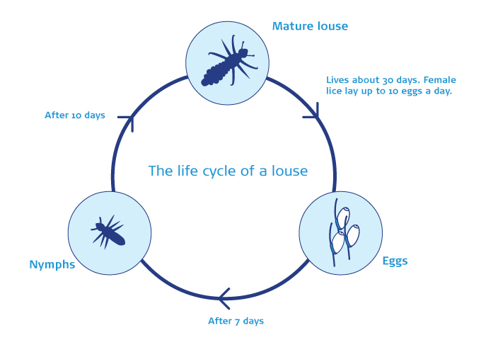
Head Lice can be difficult to see even when the hair is closely inspected. It can be difficult to distinguish between eggs and nits (empty eggshells) that are dead or alive. Nits can also remain glued to hairs long after a successful treatment.

Detection Combing is the best way of finding Head Lice. It involves using a special fine-toothed Head Lice comb with a tooth spacing of 0.2-0.3mm to comb through the hair. The comb can trap the smallest Lice. It works best on wet hair but it can also be used on dry hair.

Comb the hair from the scalp outwards, section by section for at least 10 minutes over a sink, bath or disposable towel. If Head Lice are present they will fall out during combing, or stick to the comb. The comb should be washed with water or wiped clean with a paper towel between each stroke.

Head Lice can usually be effectively treated with lotions or sprays designed to kill Head Lice, or by wet combing with the already mentioned Head Lice Comb. Wet combing can be used without lotions or sprays , but it needs to be done regularly and thoroughly.

Your local pharmacist will be able to recommend an over-the-counter lotion or spray and give you advice on how it can be used correctly. It is difficult to prevent a Head Lice infestation because they are spread by head-to-head contact. Regular Detection Combing on a weekly basis is the best way to find new Lice quickly.

As a school, we encourage Parents/Carers to:
- Prevent Head Lice by regular shampooing, conditioning and daily combing of the hair.
- Detect Head Lice using a fine tooth plastic or detector comb on a weekly basis.
- Treat Head Lice as soon as an infestation becomes apparent.
- Alert friends, family and the school if Head Lice are detected, and letting them know that treatment is being undertaken.

If we all act together we should be able to reduce the occurrence of Head Lice.

